Programming Fundamentals Lab Assignment #3

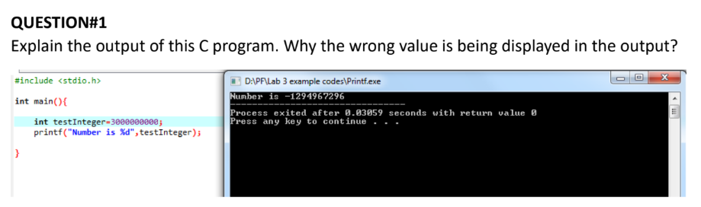

Answer) The number declared is too long to be stored in int data type because int only holds 4 bytes of data, using long int will resolve this issue.

Q2] Write a C program that takes two integer values as input from the user. Then swap the values taken from the user and display the output of the variables.

Answer)

#include <stdio.h>

int main() {

int a;

int b;

int c;

printf("Please enter your first number, a : " );

scanf("%d",&a);

printf("Please enter your second number, b : " );

scanf("%d",&b);

c=a;

a=b;

b=c;

printf("a is: %d",a);

printf("\nb is: %d",b);

return 0;

}

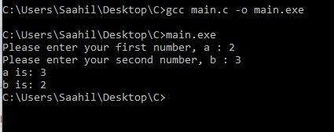

Q3] A customer asks the IT firm to develop a program in C language, which can take tax rate and salary from the user on runtime and then calculate the tax, the user has to pay and the salary he/she will have after paying the tax. This information is then provided to the user.

Answer)

#include <stdio.h>

int main () {

float salary, tax, gross;

printf("Please enter your basic salary : ");

scanf("%f",&salary);

printf("Please enter the tax rate : ");

scanf("%f",&tax);

gross=(salary)-(salary\*tax/100);

printf("Your gross salary after tax deduction is : %.2f",gross);

return 0;

}

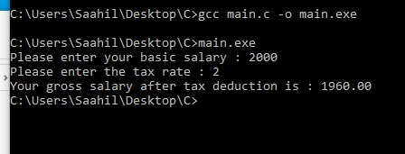

Q4] A car travelled back and forth from point A to point B. With a distance being (single trip) 1207KM. During the forward trip fuel price was 118/liter while returning it was 123/liter. Calculate the total fuel cost (both ways) and the fuel consumed (total trip). Use the car’s fuel average as input from the user (Input must be positive make some restrictions on only accepting positive input).

Answer)

#include<stdio.h>

int main () {

int fwd=118;

int bwd=123;

int d=1207;

float avg, fuel, cost;

printf("Please enter the fuel average of your car : ");

scanf("%f",&avg);

if (avg>0){

fuel=(2\*d/avg);

printf("The total fuel consumed is: %f liters",fuel);

cost=((fuel/2)\*fwd)+((fuel/2)\*bwd);

printf("\nThe total fuel cost for the trip is : %f Rupees", cost);

}

else printf("Please enter a valid positive average");

return 0;

}

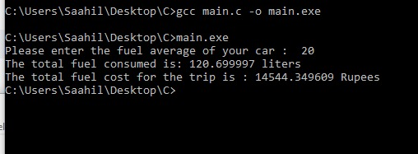

Q5] Construct a C program with the flowchart below. The input value of the principle must be between 100 Rs. To 1,000,000 Rs. The Rate of interest must be between 5% to 10% and Time Period must be between 1 to 10 years. Hint: these restrictions can be displayed in the form of message on the window.

#include<stdio.h>

int main () {

float P,R,T,SI;

printf("Please enter your principal amount between 100 and 1000000 rupees: ");

scanf("%f",&P);

if (P>=100 && P<=1000000){

printf("Please enter your rate of interest between 5 and 10 percent: ");

scanf("%f",&R);

if(R>=5 && R<=10){

printf("Please enter the time period between 1 and 10 years: ");

scanf("%f",&T);

if(T>=1 && T<=10){

SI=(P\*T\*R/100);

printf("The simple interest amount is : %.2f rupees",SI);

} else

{printf("Time does not lie between range, error.");

}

}else

{printf("Rate does not lie between range, error.");

}

} else

{printf("Principal does not lie between range, error.");

}

return 0;

}

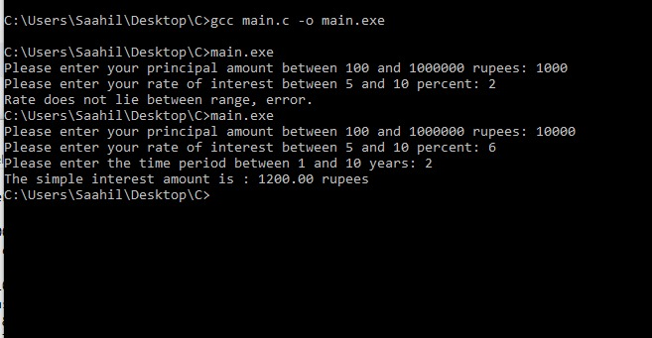

Q6] Construct a C program where you calculate the slope of two point (5,4), (3,2). Use format specifiers to cap the result to 3 decimal places.

Answer)

#include<stdio.h>

int main () {

float x1, x2, y1, y2, gradient;

printf("Please enter the x-coordinate of the first point : ");

scanf("%f",&x1);

printf("Please enter the y-coordinate of the first point : ");

scanf("%f",&y1);

printf("Please enter the x-coordinate of the second point : ");

scanf("%f",&x2);

printf("Please enter the y-coordinate of the second point : ");

scanf("%f",&y2);

gradient=(y2-y1)/(x2-x1);

printf("The gradient/slope of these two points upto three decimal places is: %.3f", gradient);

return 0;

}

